|  |
| --- |
| **LAB 4** |
| SOAP AND RESTFUL SERVICES |
|  |
| This assignment deals with the creation of SOAP and RESTFUL Services along with the mobile web client application and making access through cloud instance. |
|  |
| **Karthik Repala** |
| **9/23/2013** |
|  |

**RESTFUL WEBSERVICES**

Go to the menu and create an WCF Service application.

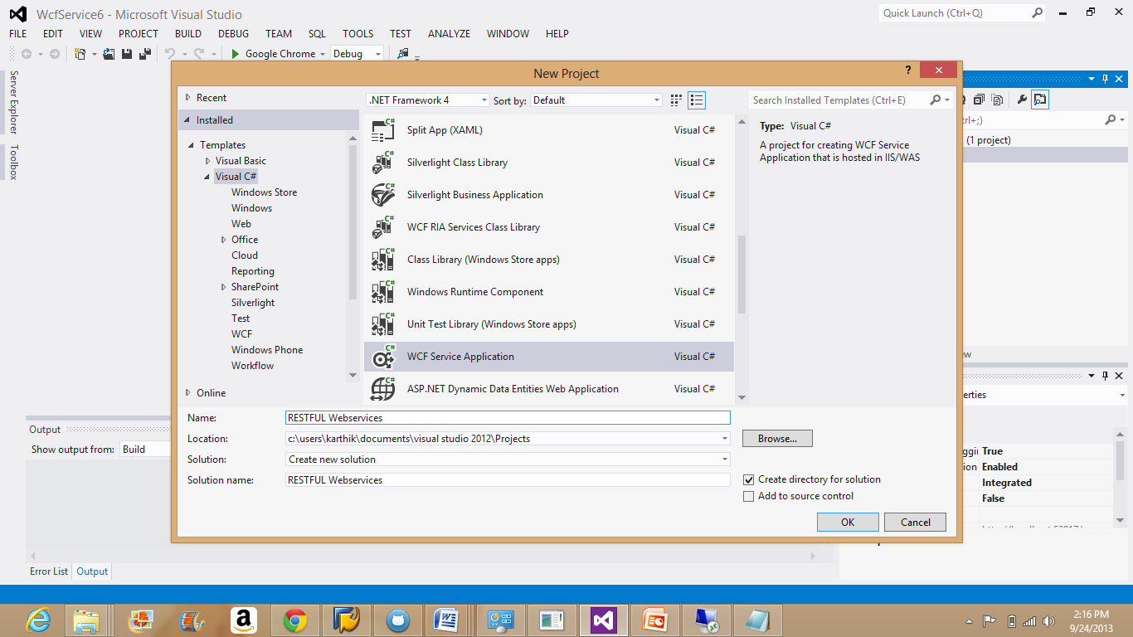

Code as per the requirement in the editor.

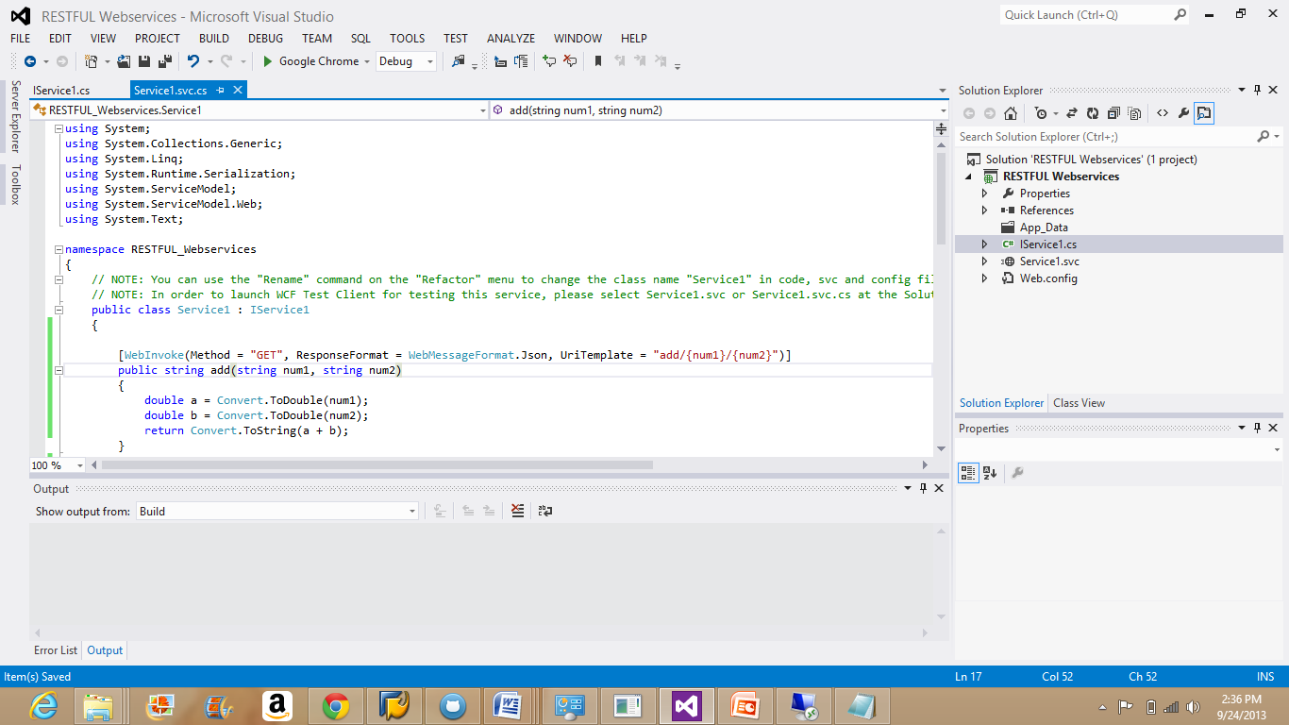

Build the code again by going into the menu Build--Build Solution.

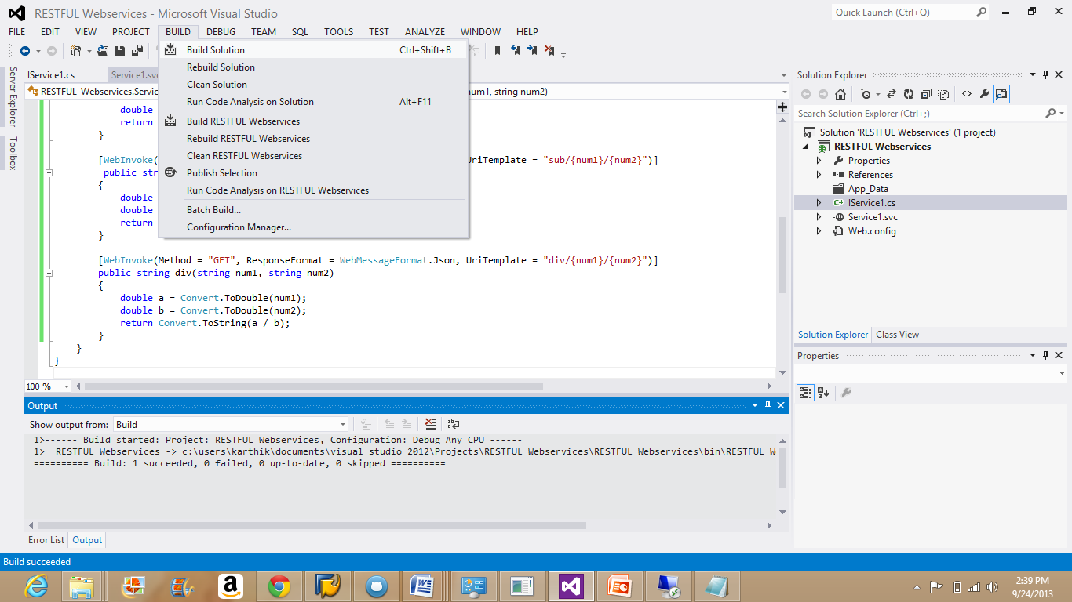

Once code gets build, debug the code by selecting the option "start without debugging".

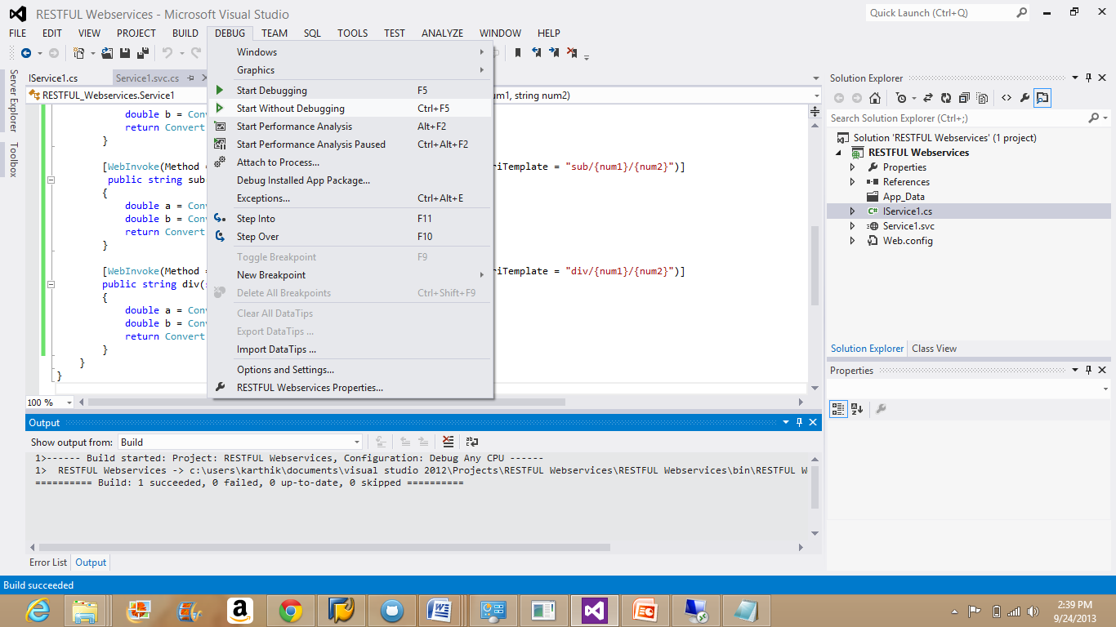

Right Click on the Service application and choose "view in browser".

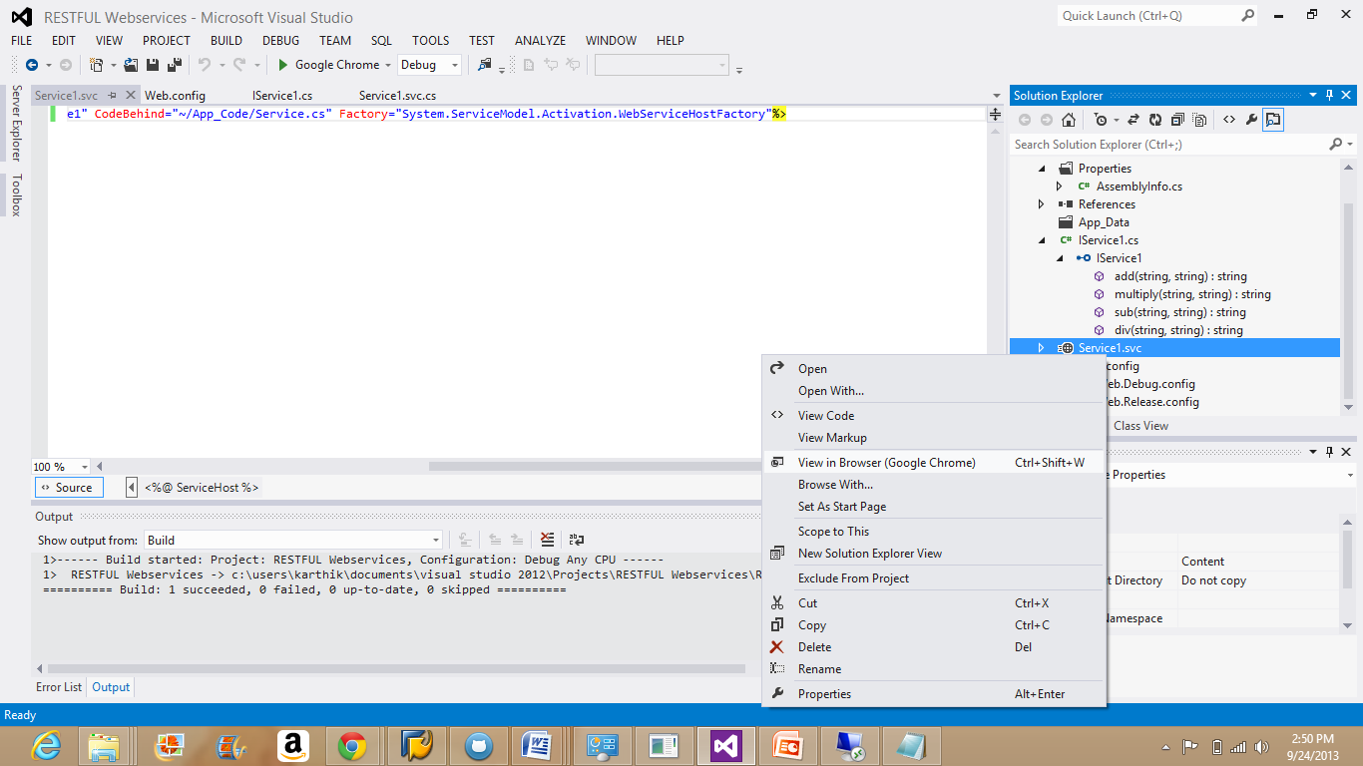

The value gets displayed when the input fields are given in the URL.

**Division:**

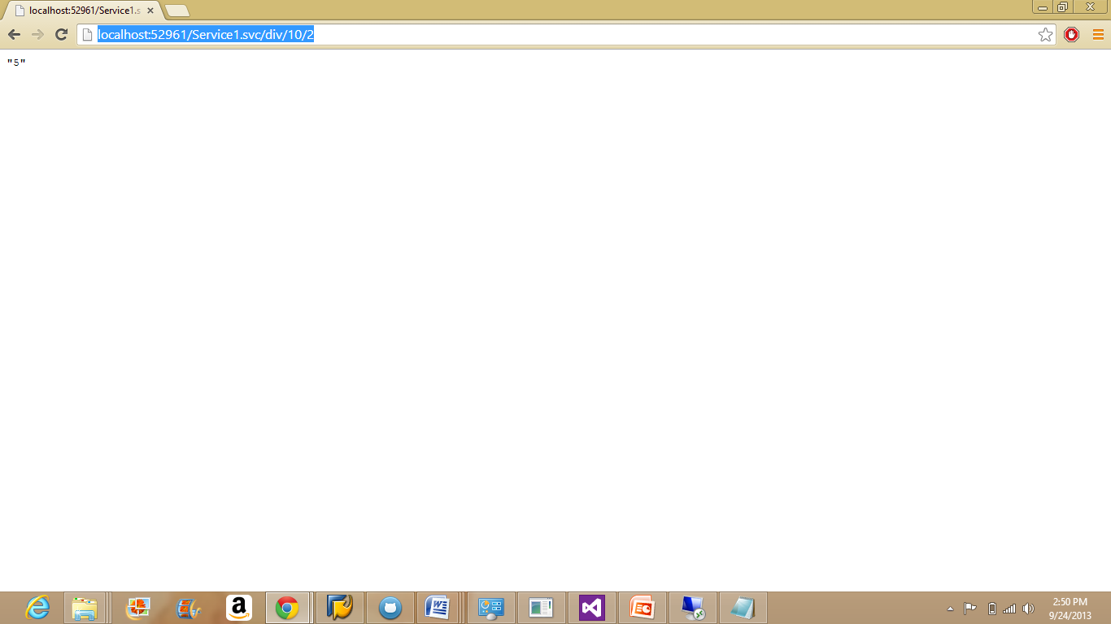

**Addition:**

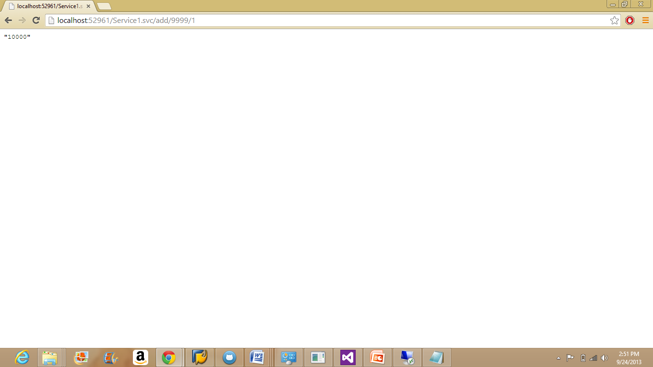

**Multiplication:**

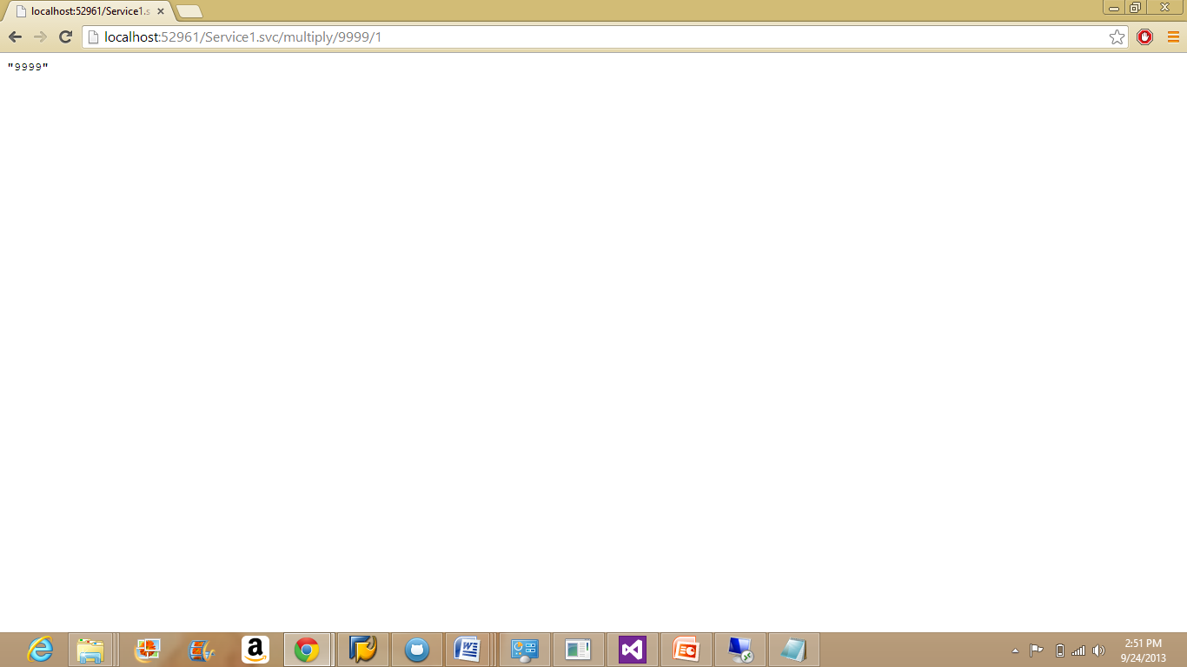

**Subtraction:**

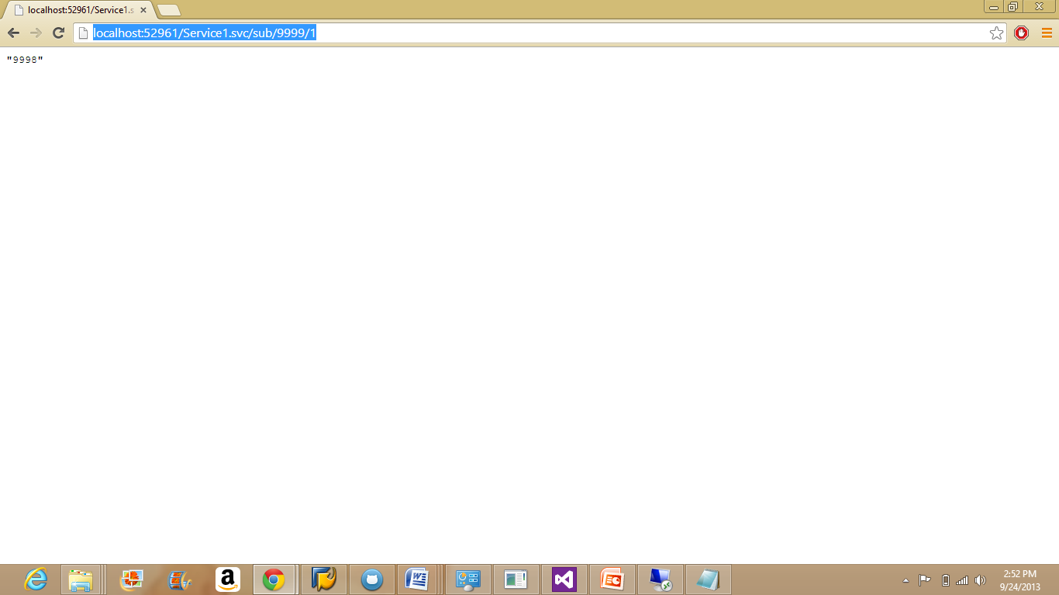

Copy the source code of Restful services into the cloud instance.

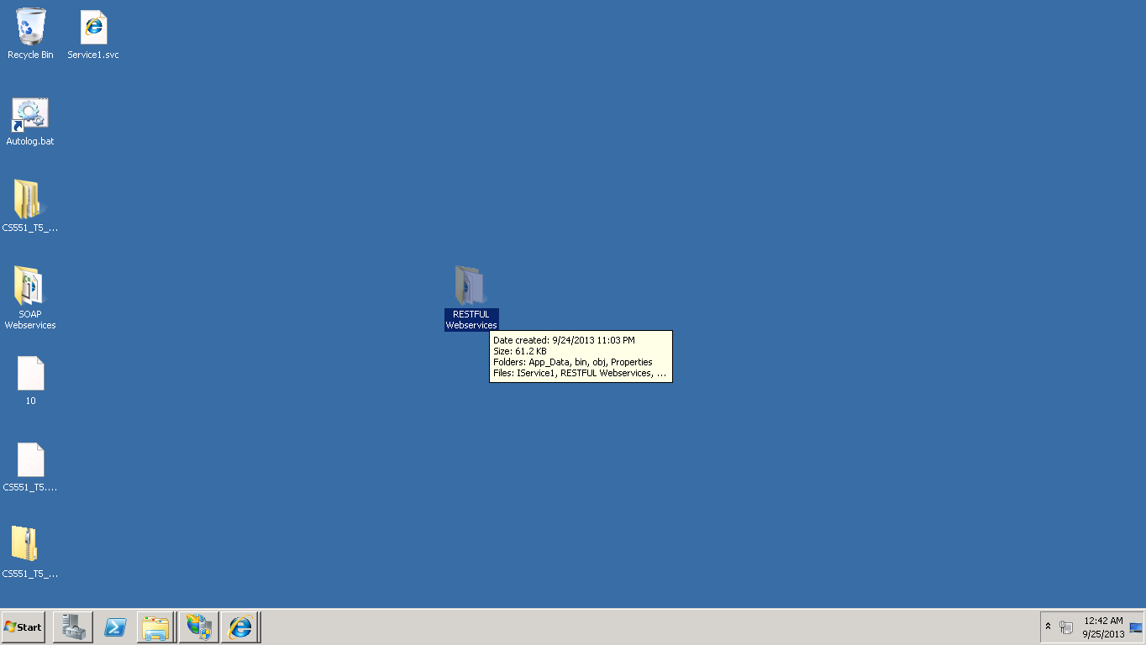

Deploy the restful services in to the remote cloud instance as the way SOAP web services are installed.

Now, convert the Restful services into an application by following the same steps used for SOAP services.

The below picture shows the SOAP and Restful services deployed into the remote instance and converted them to applications.

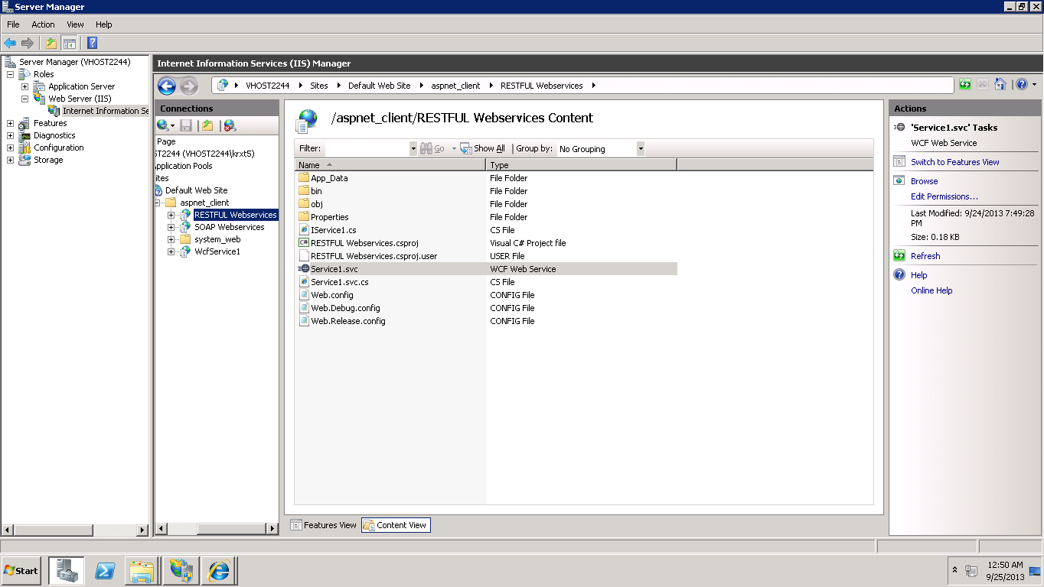

This will complete creating SOAP and Restful Web services.